
Educate Together Secondary School Wicklow
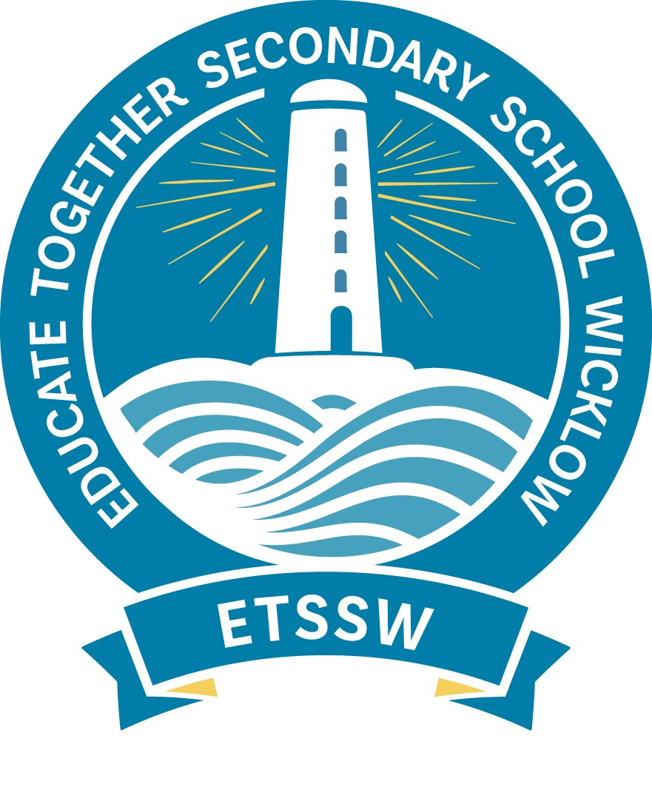

Agreed Board Management Report January 2026

- New Board of Management Introduction
Danny Haskins- Chairperson
Nicholas Sweetman- Patron Representative
Mandy Hensley- Parent Representative
Cillian McCarthy- Parent Representative
Grace Ferrick- Staff Representative
Jake Firman- Staff Representative
Community Representatives- TBC

- Student Council Report
Hollyanne Armstrong & Sophia Van Der Linden- delivered the Student Council Report and introduced Caoimhe Doyle as the new link teacher and spoke about policies the Student Council have reviewed and ideas for upcoming fundraisers for Valentines. Board approval given for fundraisers.

- DEIS Action Update
Owen Morris (AP1) gave an update on our DEIS Action Plan.

- Policy Review
    - Bí Cinneálta Policy- ratified (from November 2025).
    - Dress Code Policy- some edits made to the policy after discussion. Ratified (from November 2025).
    - Cooperating Teacher and PME Policy- ratified (from November 2025).
    - Code of Behaviour- ratified
    - Student Council Policy- ratified
    - Attendance Policy- ratified

- Staff Report
- Grace delivered the staff report which included highlights such as planning for the TY Musical, Schools of Sanctuary Project update, Erasmus planning Trips to Poland and Romania, boys Football Team reaching the finals with Francisco, 1st Year History trip to Dublinia Museum, Girls GAA team qualifying for the quarter final, marking a major milestone for the school in this competition, our 5th year CASD students organised the Our Future, Our Climate conference in collaboration with Wicklow County Council and Codling Wind Park.

- Parent Staff Association

The PSA committee representatives were elected for 2025/26:
Tara Crawford (Chairperson)
Elaine O’Callaghan (Vice Chairperson)
Koryne Smyth (Secretary)
Roisin Byrne (Treasurer)
The Winter Fair was held on Wednesday Dec 3rd and raised €613.60- a big thank you to all who supported the event.
Date for the next meeting: March 26th 2026

